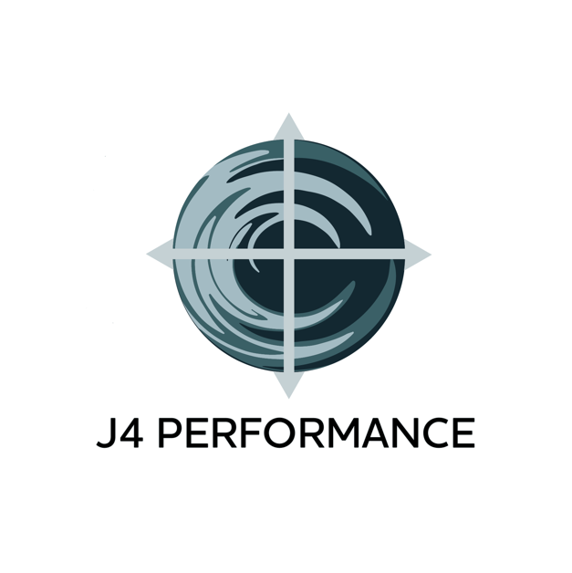
Welcome Teammate!

Name:

Date:

- What motivated you to join us?

- What type of games/activities do you enjoy with your friends? (i.e., hiking, quadding, riding a bike, etc.)

- What sports, if any, do you play? Are you Right- or Left-handed?

- What qualities do you want/expect from Jimmy as a coach?
(i.e., encouraging, challenging, etc.) Please list at least 1.

- In what ways do you hope the U12 development program will benefit your youth participant(s) outside of our sessions?

- Do you have any family members or friends that you would like to share this experience with?

Informed Consent

PURPOSE AND EXPLANATION OF PROCEDURE

I hereby consent to voluntarily engage in an acceptable plan of personal/group fitness training. I also give consent to be placed in personal/group fitness training program activities which are recommended to me for improvement of health/fitness education activities. The levels of exercise I perform will be based upon my cardiorespiratory (heart and lungs), muscular fitness and mental capacity. I understand that I may be required to undergo a graded exercises test prior to the start of my personal/group fitness training program in order to evaluate and assess my present level of fitness. I will be given exact personal instructions regarding the amount and kind of exercise I should do. A professionally trained coach will provide leadership to direct my activities, monitor my performance, and otherwise evaluate my effort. I understand that I am expected to follow staff instructions with regard to exercise, stress management, and other health and fitness regarded programs. If I am taking prescribed medications, I have already, or will, inform the program staff and further agree to so inform them promptly of any changes which my doctor or I have made with regard to use of these. I have been informed that during my participation in the above described personal/group fitness training program, I will be asked to complete the physical activities unless symptoms such as fatigue, shortness of breath, chest discomfort or similar occurrences arise. At this point, I have been advised that it is my complete right to decrease or stop exercise and that it is my obligation to inform the personal fitness training program personnel of my symptoms, should any develop. I understand that during the performance of exercise, a personal/group fitness coach will periodically monitor my performance or assess my feelings of effort for the purposes of monitoring my progress. I also understand that during the performance of my personal fitness training program, physical touching and positioning of my body may be necessary to assess my muscular and bodily reactions to specific exercises, as well as to ensure that I am using proper technique and body alignment. I expressly consent to the physical contact for the stated above reasons.

RISKS

It is my understanding and I have been informed that there exists the remote possibility during exercise of adverse changes including, but not limited to, abnormal blood pressure, fainting, dizziness, disorders of heart rhythm, and in very rare instances heart attack, stroke, or even death. I further understand and I have been informed that there exists the risk of bodily injury including, but not limited to, injuries to the muscles, ligaments, tendons, and joints of the body. Every effort, I have been informed, will be made to minimize these occurrences by proper staff assessments of my condition before each personal/group fitness training session, staff supervision during exercise and by my own careful control of exercise efforts. I fully understand the risks associated with exercise, including the risk of bodily injury, heart attack, stroke, or even death, but knowing these risks, it is my desire to participate as herein indicated.

BENEFITS TO BE EXPECTED AND ALTERNATIVES AVAILABLE TO EXERCISE

I recognize that involvement in the personal/group fitness training sessions will allow me to learn proper ways to perform conditioning exercises, use fitness equipment and regulate physical effort. These experiences should benefit me by indicating how many physical limitations may affect my ability to perform various physical activities. I further understand that if I closely follow the program instructions, that I will likely improve my exercise capacity and fitness level after a period of 1-6 months. I understand that the significance of my results will vary based on the program length that I commit to (i.e., 8 sessions compared to 24 sessions).

CONFIDENTIALITY AND USE OF INFORMATION

I have been informed that the information which is obtained in this personal/group fitness training program will be treated as privileged and confidential and will consequently not be released or revealed to any person, to the use of any information which is not personally identifiable with me for research and statistical purposes so long as same does not identify my person or provide facts which could lead to my identification. Any other information obtained, however, will be used only by the program staff to evaluate my exercise status or needs.

INQUIRIES AND FREEDOM OF CONSENT

I have read this Informed Consent form, fully understand its terms, understand that I have given up substantial rights by signing it, and sign it freely and voluntarily, without inducement.

Participant’s Name (Please Print):

Participant’s Signature:
(Parent’s signature if under 18 years of age)

I represent that I have legal capacity and authorize to act on behalf of the minor named herein.

Parent/Guardian Name (Please Print):

Parent/Guardian Signature:

Date:
Waiver of Liability for Facility Use

I/We hereby understand and acknowledge that the training, programs and events held by J4 Performance may expose me to many inherent risks, including accidents, injury, illness, or even death. I/We assume all risks or injuries associated with participation including, but not limited to, falls, contact with other participants, the effects of the weather, including high heat and/or humidity, and all other such risks being known and appreciated by me.

I/We hereby acknowledge my responsibility in communicating any physical and psychological concerns that might conflict with participation in activity. I/We acknowledge that I am physically fit and mentally capable of performing the physical activity I choose to participate in.

After having read this waiver and knowing these facts, and in consideration of acceptance of my participation and J4 Performance furnishing services to me, I agree, for myself and anyone entitled to act on my behalf, to HOLD HARMLESS, WAIVE AND RELEASE J4 Performance, its officers, agents, employees, organizers, representatives, and successors from any responsibility, liabilities, demands, or claims of any kind arising out of my participation in J4 Performance training, programs and/or events.

By my signature I/We indicate that I/We have read and understand this Waiver of Liability. I am aware that this is a waiver and a release of liability and I voluntarily agree to its terms.

Participant’s Name (Please Print):

Participant’s Signature: Date:
(Parent’s signature if under 18 years of age)

In case of emergency, contact: Phone:

I represent that I have legal capacity and authorize to act on behalf of the minor named herein.

Parent/Guardian Name (Please Print):

Parent/Guardian Signature:

Date:

Policies and Procedures

TARDINESS POLICY

You are expected to begin training at the start time of the scheduled appointment. If you are training with a group, we may be able to wait for you if you are going to be a few minutes late, but please do not rely on us to do so regularly in respect of other people’s time. In any case that you may be late, please text 780-864-7641 to inform me so that we can try to accommodate you. As an example, if you are 10 minutes late for a 60-minute training session, I would be happy and willing to finish 10 minutes later than our scheduled appointment if my schedule permits. Otherwise, your session may be reduced to 50 minutes. Exceptions will be made based on the coach’s schedule/availability.
Initials

CANCELLATION & RESCHEDULING

While I make every effort to be flexible and accommodate your schedule, I will do so under the following conditions:

If you need to cancel an appointment/training session you must do so by texting, calling, or emailing me 6 hours before the appointment time. If I am not available, please leave a message. I will check my availability and get back to you with confirmation of the rescheduled date and time as soon as possible. If for some reason, you do not text, call, or email me 6 hours before your appointment time and do not show up, you will forfeit your training session. The only exception to this policy is a medical emergency accompanied by a doctor’s note.

If special circumstances are necessary, and my schedule permits, we may agree upon a shorter notice period, in which case you will not forfeit your training appointment/session. The determination of which circumstances warrants, or my schedule permits, are decisions that will be left to my sole discretion and determined on a case-by-case basis. In the case that the training facility is outdoors, additional accommodations will be considered. In the case that weather is not conducive to training, and we are unable to utilize an indoor space, your training session will not be forfeited, and your session(s) expiration date will be pushed back to accommodate for the appointment cancellation and rescheduling. In any case that weather prevents the ability to train outdoors for consecutive days and we are unable to utilize an indoor space, the same accommodations will be made in reference to pushing back expiration dates. The coach has the right to cancel and reschedule any scheduled training sessions due to restrictions imposed by inclement weather (rain, thunder, lightning, heat) that would make it an unsafe training environment. The coach will contact all participants at least 30 minutes prior to the beginning of the scheduled appointment to confirm or cancel a scheduled training session.
Initials

I have read and understand all the policies and procedures listed above.

Participant’s Name (please print):

Participant’s Signature: Date:
(Parent’s signature if under 18 years of age)

I represent that I have legal capacity and authorize to act on behalf of the minor named herein.

Participant’s Name (Please Print):

Parent/Guardian Signature:

Date:

Health & Medical Questionnaire

Name: Date of birth: Date:

Address:
Street City Province Postal Code

Phone (Cell): (Secondary):

Email Address:

In case of emergency, whom may we contact?

Name: Relationship:

Phone (Cell): (Secondary):

Personal Physician:

Name: Phone:

Please list any medications that you are currently taking:

PRESENT/PAST HISTORY

Have you had or do you presently have any of the following? (Check if yes)
Rheumatic fever
Recent operation
Edema (swelling of ankles)
High blood pressure
Low blood pressure
Back injury
Knee injury
Seizures
Lung disease
Heart attack or known heart disease
Fainting or dizziness
Diabetes
High cholesterol
Orthopnea (the need to sit up to breath comfortably)
Nocturnal dyspnea (shortness of breath at night)
Shortness of breath at rest or with mild exertion
Chest pains
Palpitations or tachycardia (unusually strong or rapid heart beat)
Intermittent claudication (calf cramping)
Pain, discomfort in the chest, neck, jaw, arms or other areas
Known heart murmur
Unusual fatigue or shortness of breath with regular daily activities
Temporary loss of visual acuity
Short-term numbness or weakness
Cancer
Other (please explain):

FAMILY HISTORY

Have any of your first-degree relatives (parent, sibling or child) experienced the following conditions? (Check, if yes). Also, please identify at what age the condition occurred.
Heart attack
Heart operation (bypass surgery, angioplasty, coronary stent replacement)
Congenital heart disease
High blood pressure
High cholesterol
Diabetes
Other serious illness (please explain):

ACTIVITY HISTORY

- Date of your last physical examination conducted by a physician:

- Do you participate in a regular fitness program at this time? Yes No

If yes, please explain and/or attach your current training program:

- Can you currently walk 4 miles briskly without fatigue? Yes No

- Have you performed weightlifting exercises in the past 3 months? Yes No

- Do you have any injuries that may interfere with training? Yes No

If yes, please explain:

- What is your current body weight? What was it one year ago?

- How tall are you?

- What is your dominant-hand? Rt Lt

Social Media Release

Film or digital photography, video photography, and/or audio recordings may be used for social media, marketing and professional use only. Publication of any and all recordings is at the full discretion of the participant. You have the right to refuse publication of specific and/or all photos, video and audio recordings.

Yes, I agree and allow my coach to share photos, videos and/or audio recordings of my performance and progression during training sessions

No, I do not agree to allow my coach to share photos, videos and/or audio recordings of my performance and progression during training sessions

I have read and understand all the social media policies listed above.

Participant’s Name (please print):

Participant’s Signature: Date:
(Parent’s signature if under 18 years of age)

I represent that I have legal capacity and authorize to act on behalf of the minor named herein.

Participant’s Name (Please Print):

Parent/Guardian Signature:

Date:

