Training “FUN”damentals

Teaching Life Skills and Healthy Habits
through Strength & Conditioning

An Integrated Health & Wellness Experience

Welcome Teammate!

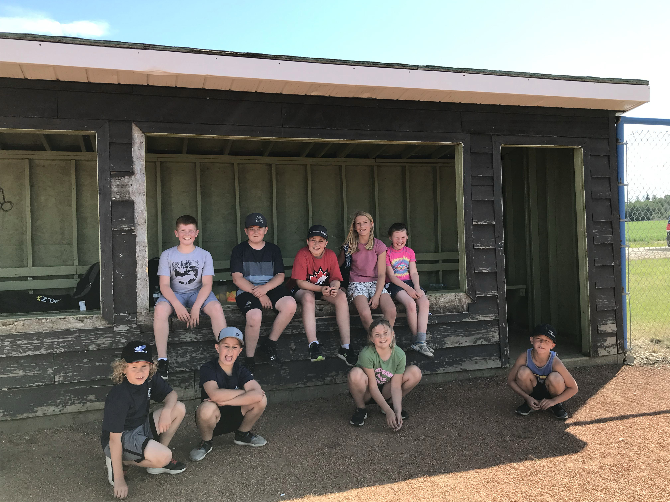

We are excited for you to join our growing team of friends!

The information included in this packet will provide you with the details you need to know about the Training “FUN”damentals program for youth between the ages of 9-11 (Grades 4-6). If we missed something, please let us know so that we can make the appropriate updates to this information packet.

For more information, please visit www.j4performance.net and always feel welcome to email jimmy@j4performance.net with any questions you may have.

For You, We Hope Health, Happiness and Success
Fitness Made FUN

Youth physical activity comes in many forms, some of the most common forms being organized sports, recreational activities, and gym class. We acknowledge that not all youth enjoy playing sports, nor may have the financial ability to do so, which is why we want to offer something different—a games-based fitness program that is engaging and interactive to provide youth student-athletes with an opportunity to improve health while having fun during the process!

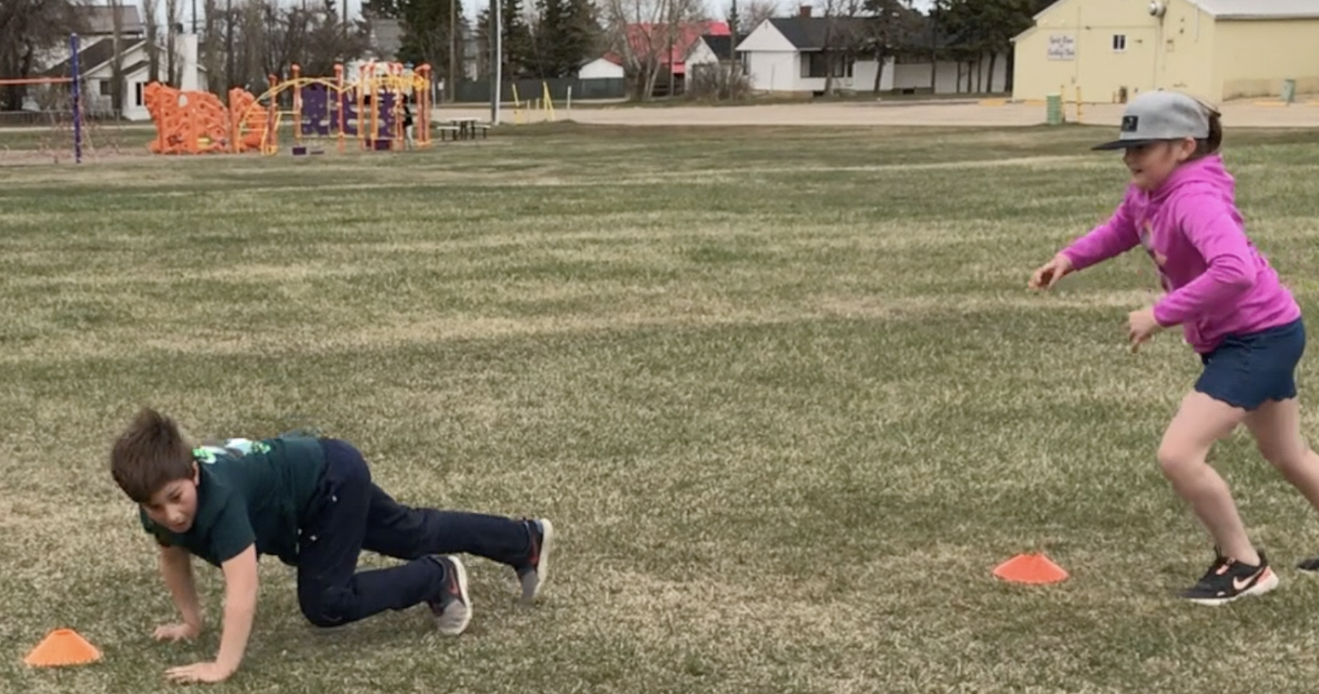

There are 3 main ways that we make fitness FUN:
- Obstacle Courses – 4 to 6 stations that focus on improving balance, coordination, power and speed—all of which are important physical qualities for long-term physical development.
- Teammate Drills – rabbit drills (refer to picture) are one of many unique ways that we turn a youthful game of TAG into something a little different. Disguised in this variation of TAG is the fact that we are teaching power, strength and starting speed, plus reaction time if you’re chasing the rabbit!
- Exercise-Based Games – Yes, we play A TON of games! Whether it’s with a deck of cards, rock paper scissors, or something the participants come up with on their own, we disguise exercises into a teammate workout or game format. The silly rabbit that said “Tricks are for Kids” didn’t know that this silly rabbit has some tricks up his sleeve too ;)
9 Core Values & Healthy Habits

Although physical activity plays a main role in our program, we use our water breaks as learning opportunities to discuss other aspects of health. Our U12 program was founded on 9 Core Values that we introduce periodically throughout the program, with the main goal of inspiring our youth to practice Core Values and Healthy Habits at home, in school and wherever life guides them.

RESPECT
Consideration for oneself, others and our surroundings

HONESTY
Being truthful to oneself and others

CONFIDENCE
Believing in oneself and others. When in doubt, take a BIG breath of confidence!

EFFORT
Doing your best, no matter what

COMMUNICATION
Engaging in two-way conversation to improve relationships with others

CREATIVITY
Coming up with new ideas for games and healthy strategies that work for them

WISDOM
Ability to make good decisions based on past successes and mistakes

AWARENESS
Being grateful for family, friends and things we get to enjoy

LEADERSHIP
Learning to lead by example within our communities

U12 Program Outline & Information

U12 Training “FUN”damentals is an after-school program that runs from September to mid-December, resuming in early January until the end of the school year. A typical session is about 1 hour and is roughly outlined as follows:

Review Team Expectations 5:00
Obstacle Course Warm Up 15:00
Core Value Discussion & Water Break 5:00
Game (i.e., participant’s choice) 5:00
Healthy Habit Discussion & Water Break 5:00
Skill of the Day: Jumping 10:00
Jumping Skill-Based Game 10:00
Water Break & Wrap Up 5:00

Current Schedule:

Spirit River Program: Tuesdays & Thursdays @ 3:30 – 4:30pm

Rycroft Program (starting Sept 27th): Mondays & Wednesdays @ 3:40 – 4:40pm

How Often Can My Child(ren) Participate?

It generally takes 6 consecutive weeks, training 2x/week to notice and gain results from one’s commitment to training. However, we acknowledge that things come up and schedules can change. If your participant(s) happens to miss a session now and then, join part or even halfway through the school year, no problem! Even if your participant(s) are involved in other sports/activities and can only attend one session per week, that’s great! We also have a 1x/week session package option to accommodate you. The most important thing for us is to provide all participants with a fun and memorable experience.

Where Are Training Sessions Held?

During the Spring & Summer months, we will plan to train outdoors at the East Ball Diamond north of the hockey arena (Spirit River participants) or at the Rycroft school grounds (Rycroft participants) unless the weather prevents us from training safely outdoors. In this case, we will train indoors. During the Fall & Winter months, we will plan to train indoors in the Centennial Hall (Spirit River participants) and in the Rycroft school gym (Rycroft participants), pending facility availability.

Because the Centennial Hall is a facility used by other local businesses, organizations and groups of people, please know that there may be times when we must relocate to a different location or cancel a class to accommodate others. I will be sure to notify you as soon as I know about any schedule changes. In the case that we do have to reschedule a class, the expiration date for purchased session packages will be extended appropriately (discussed more later).

What Does My Participant Need To Bring To Sessions?

- Filled water bottle (water bottles will be available if needed)
- Gym / Court shoes. For safety reasons, PLEASE NO SANDALS
- Athletic or comfortable attire to run around in (PLEASE NO JEANS)
- Medications for special considerations (i.e., inhaler)

How Much Physical Activity is Too Much?

Our training sessions range between moderate- to high-intensity physical activity and includes planned water breaks. A general, minimum daily recommendation for physical activity in youth ages 9-11 is about 60-minutes of moderate- to high-intensity activity. Sports, gym class, and even playing outside can fall within this range. It is not uncommon for participants to come to our sessions before engaging in a sports practice or other extra-curricular activity. All participants will be provided with an apple to take with them on-the-go to help provide an energy boost.

The above recommendation of 1-hour is a minimum, not a maximum. My best recommendation is to ask your children questions like, “How are you feeling today?” and “On a scale of 1-10, how sore do you feel?” Ask these and similar questions often, and especially after days when they have participated in gym class, our training sessions, and a sports practice/extra-curricular activity. Children tend to be very good at listening to their bodies, meaning that they will have a nap or fall asleep early if they are tired.

In the case that your participant is experiencing muscle soreness that lasts for two or more days, or is getting worse after two days, REDUCE the amount of physical activity until they have fully recovered. Kids need rest sometimes too =)
Program Value & Cost

Initiation Package**

30-min Youth & Parent Consultation $45
+
(8) Small Team Training Sessions (valid for 4 weeks) 8 x $22.50/session = $180
=
TOTAL (tax included): $225

**All new participants receive a J4 Performance youth athletic shirt ($25 value), which is included in the total price of the Initiation Package.

Future Pricing Following Initiation Package

8 sessions (valid for 4 weeks) 8 x $22.50/session = $180

4 sessions (valid for 4 weeks) 4 x $25/session = $100

Added Value for All Participants

Fresh apples are included for all participants and will be provided at the end of every training session.

If your participant is unable to eat applies (i.e., braces), oranges will be provided instead of apples.

Save $$ When You Sign Up With A Family Member

If you have more than one child that is interested in joining our program, the cost of the Youth & Parent Consultation will remain as $45.

To help offset the overall price for families (i.e., sister and brother participants), we offer family discounts for every additional family member that signs up for one of our J4 Performance services. For example….

If a sister and brother sign up for the U12 Training “FUN”damentals program, the cost for one participant is $180 (8 sessions) and the cost for the 2nd participant is $160 ($2.50/session discount), equaling $340 for both to participate in 8 sessions.

In the case that three sisters/brothers sign up, the 2nd and 3rd participants fees will be discounted by $4.50/session ($180 + $144 + $144 = $468).
4 Simple Steps To Join

Step 1: Complete Pre-Participation Packet

These forms will provide me information about an individual’s past and present state of health so that I can gain a basic understanding of wants, needs and any special considerations (i.e., asthma). Also included in this packet are the Informed Consent and Social Media Waiver forms that need to be filled out completely.

Please visit https://www.j4performance.net/youth-development to download the U12 pre-participation forms, complete every section of the document, and then either scan and email the completed forms to jimmy@j4performance.net. You can also bring the completed forms with you to our consultation.

If you’re unable to download the forms using the web link provided, please email me so I can share them with you.

Step 2: Schedule Your 1:1 Consultation w/ Coach Jimmy Nicholson

This meeting is a great opportunity to build a relationship with you and your youth participant(s). We will also discuss what you’d like your participant(s) to gain from participating in this program, some general health recommendations, and further discuss the information you shared in the pre-participation packet. Anything and everything are up for discussion, so please feel welcome to ask as many questions as you would like, whether it’s program-related or not. I love questions and will have some questions to ask you as well =)

This consultation can take anywhere from 20-30 minutes, so please accommodate for 30-minutes. Ideally, we will be able to meet in-person, but I can understand that parent responsibilities can make it difficult to do so. If this is the case for you, I would be happy to have our consultation over a zoom meeting or phone call.

Step 3: Submit Payment

Once you schedule a day & time to meet w/ Coach Jimmy for your consultation, the next step is to submit payment via e-transfer of $225 (Initiation Package) to jimmy@j4performance.net PRIOR TO meeting for our consultation. If you would prefer to pay by cash or cheque, please bring $225 with you to our consultation.

Please feel welcome to inquire about setting up a payment plan if you need. I am more than willing to make accommodations for those who are financially limited during these uncertain times.
Step 4: Join A Pre-Existing Team

Our current team members are fun and outgoing young people who support one another. Although some participants have been training with us for a while, Coach Nicholson acknowledges that everyone is at their own unique level and progresses at their own rate. Obstacle courses, exercises, and all aspects of a training session can be adjusted to meet your participant’s individual needs.

Jimmy also makes a point to connect with all participants multiple times throughout the class, and of course, you are always welcome (actually, encouraged =)) to ask any questions that you may have.
In the case that you want to create your own team, please contact family friends and other parents who may be interested in having their kid(s) join us.

Our current max limit per session is 8 participants. If there is space available on one of our current small teams, you are more than welcome to join us!

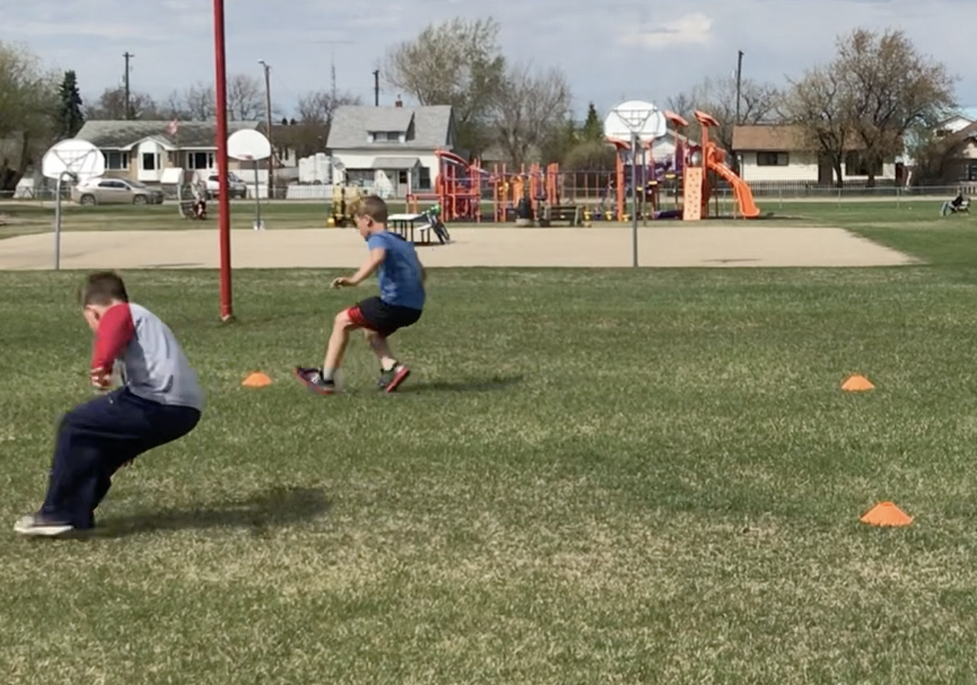

Please share this information packet with family friends and all others who may be interested in joining our program
Jimmy Nicholson, MS, CSCS, RKC

Strength & conditioning coach, Jimmy Nicholson, has enjoyed working with young people dating back to 2007 when he began volunteering with the Chinook Valley junior golf program. Four years later, he began volunteering with The First Tee of Phoenix—a junior golf program that teaches life skills through the game of golf. His overall experience inspired him to become a junior golf instructor at the Fernie Golf & Country Club for 3 years, teaching kids in kindergarten to grade 9. In 2015, Jimmy went back to school to follow a newly discovered passion for health & fitness, eventually leading to new opportunities to work with young people.

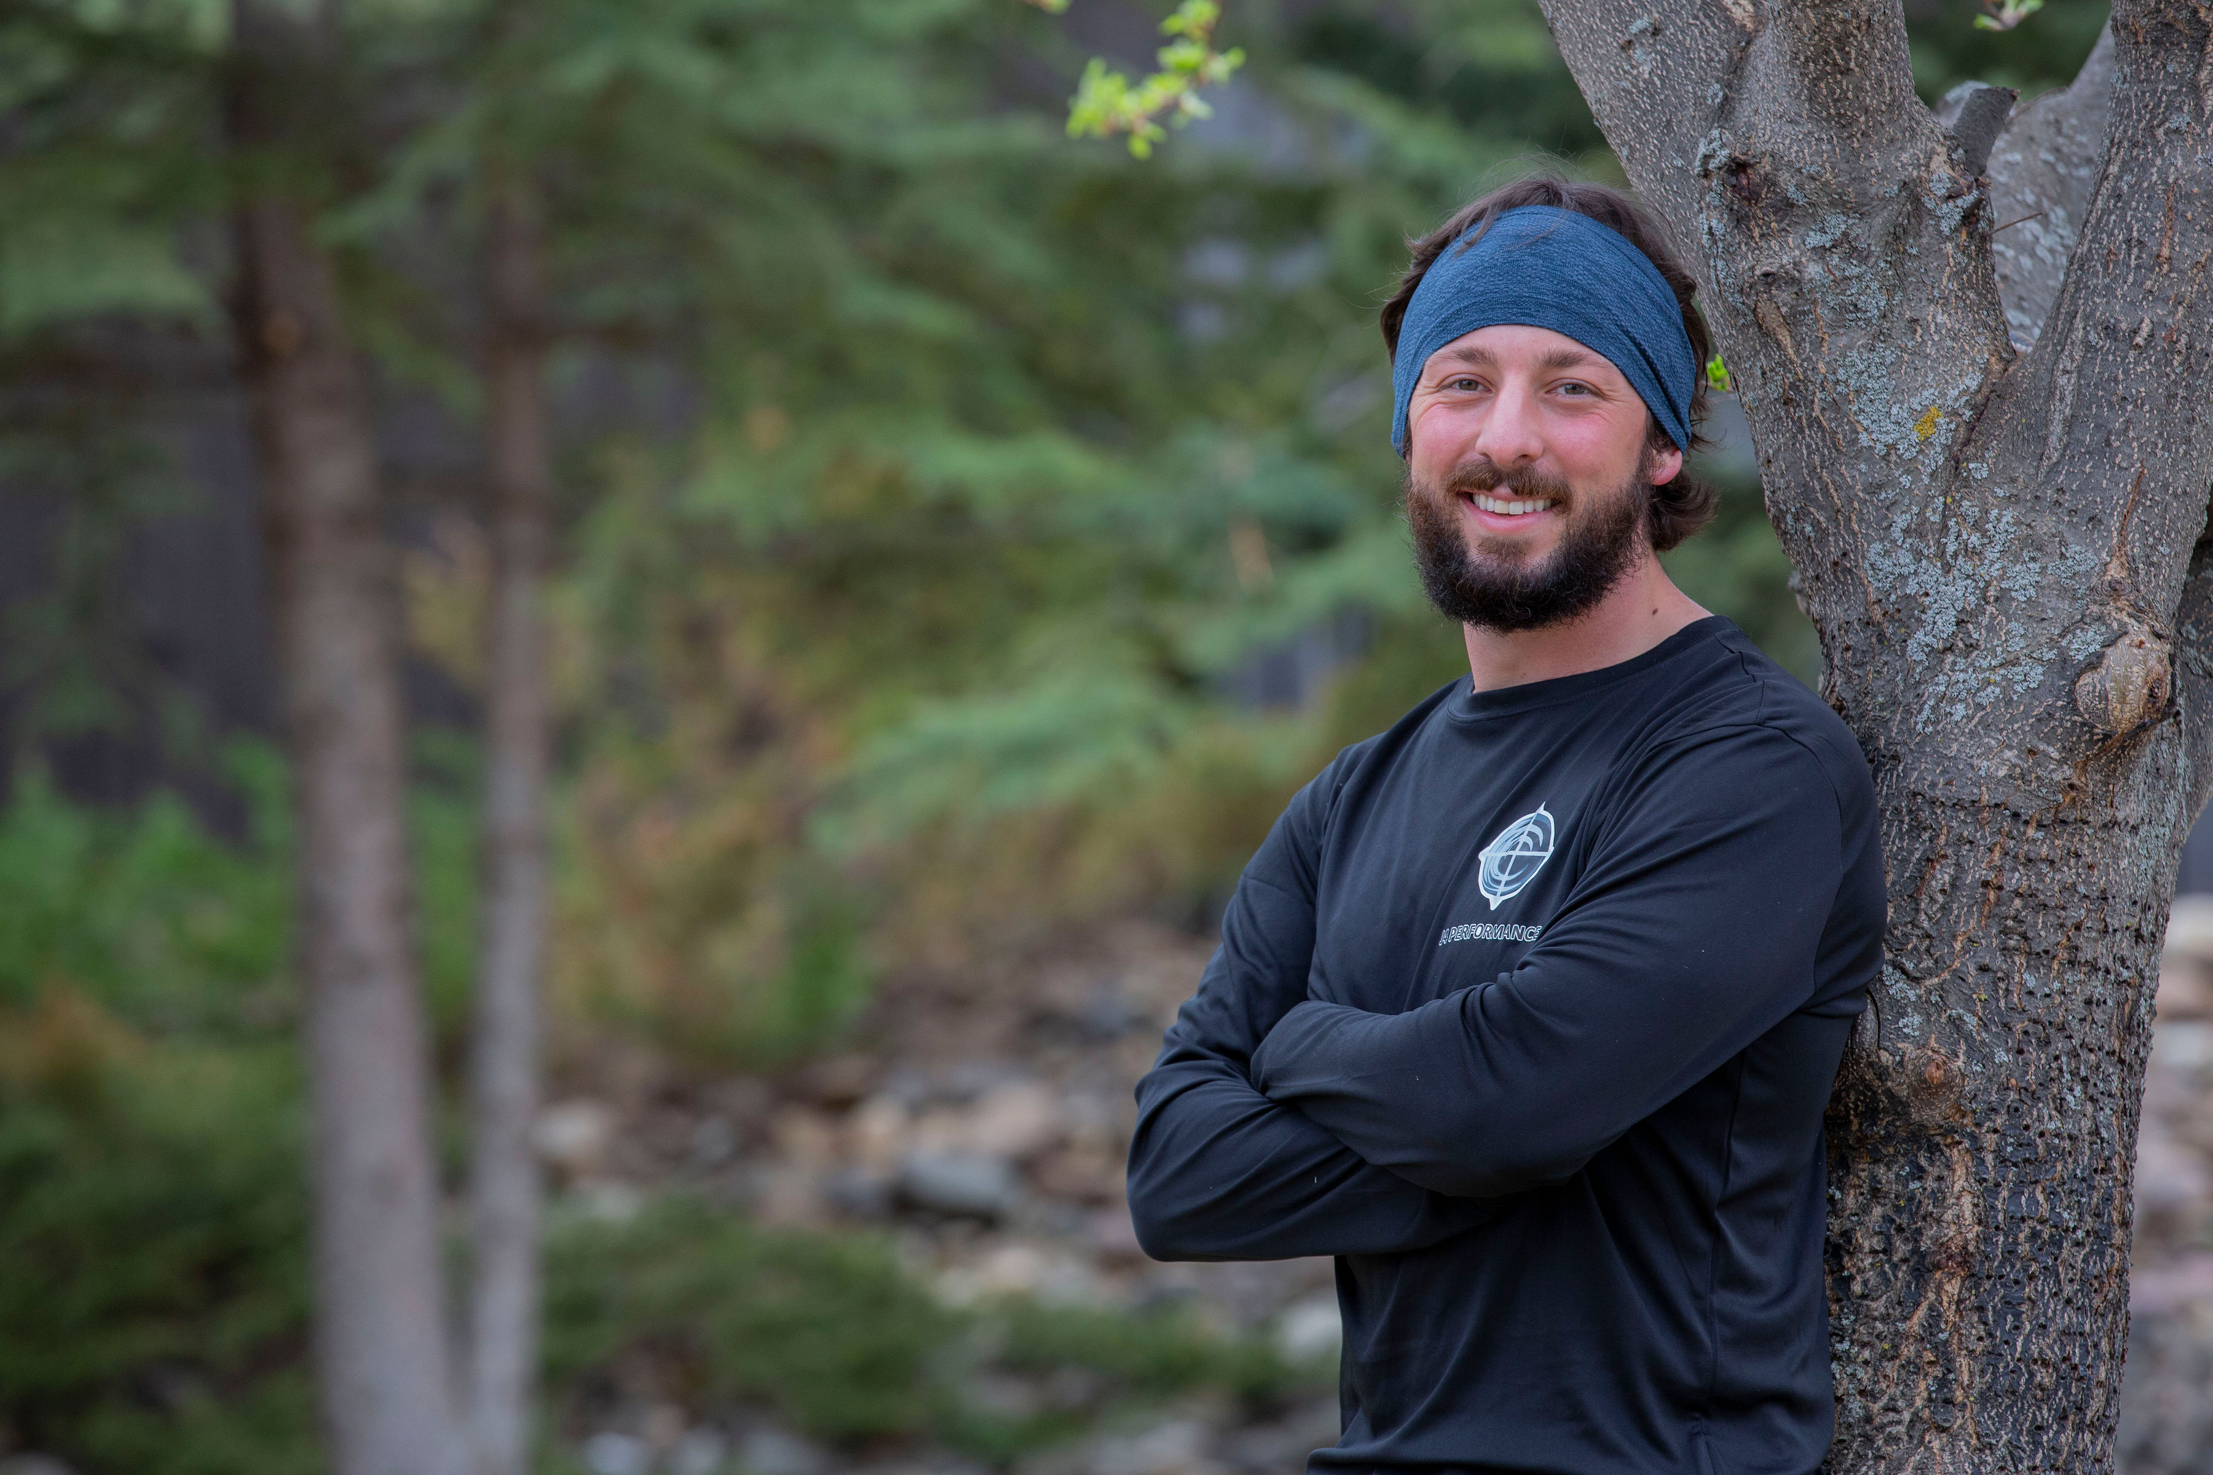

In 2016, Jimmy worked part-time as a junior golf instructor for The First Tee once again, but this time, with the Chapter of Greater Pasadena. This opportunity inspired him to start a youth fitness program while earning an M.S. in Leadership & Management. Now back in the Peace Country, Jimmy is honored to follow the footsteps of local teachers, coaches, mentors and parents. As your coach, his intention is to inspire young people to practice healthy habits and provide them with fun and memorable experiences, over delivering in the process.

